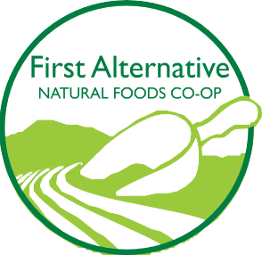
NORTH STORE · 2855 NW Grant Ave. Corvallis, OR 97330 · 541-452-3115
SOUTH STORE · 1007 SE Third St. Corvallis, OR 97333 · 541-753-3115

www.firstalt.coop

2024 Beans for Bags Nomination Form
As you are filling out this form, keep in mind that our Co-op Owners may need a refresher on who you are, what you do, and how your organization impacts the community. What sets you apart from other organizations that do similar work? What kind of proven success do you have at doing what you do best? How will Beans for Bags donations help you achieve your goals? It’s important to communicate the great work that you do to our Owners, so they will be encouraged to vote for you!
Please note that by providing information on this form, you are giving us permission to reprint and publish it on all in-store and digital communication platforms. If you have any questions, please contact Donna Tarasawa, Outreach Specialist, via email: donnax@firstalt.coop or via phone: 541-753-3115 ext. 7101. If you applied last year, we should be able to email you a copy of your application to refer to in preparing this year’s application.
- Organization Information
Name of your organization:

Name and title of contact person:

Email address of contact person:

Phone number:

Mailing address:

Non-profit Tax ID Number:

- What is your organization’s mission?

- Is there any other information you would like to share about your organization?

Submission information:
- When you save this document, please “SAVE AS” and change the title using this name template: Your org’s name-BFB2021. We will accept MS Word and PDF formats.
- Email completed application to donnax@firstalt.coop
- Application must submitted by 9pm on August 31, 2023.

Other helpful information:
- Beans for Bags Elections will be held from October 1-31, 2023.
- Only Co-op Owners are eligible to vote.
- You will be notified of the election results in December 2023.
- If your organization is chosen to be a recipient, you will be assigned 3 months in the following year when your organization will be showcased on the in-store display.
- During the quarter in which you are featured, please encourage your supporters to shop with us and help support your organization by participating in Beans for Bags.
- First Alternative Co-op donates $1,000 per quarter to the Beans for Bags recipients, which is divided amongst 4 organizations, according to how many tokens are put into each slot.
- Donation checks are mailed to the address provided on this application. If there is a change of address or contact person after you submit your application, please be sure to send notification of the changes to donnax@firstalt.coop

Please route completed applications to Donna T (South Store)

